DSE ZG556 — Stream Processing and Analytics
Situated Learning Assignment
Domain — Smart Cities & Urban Infrastructure

Team Members:

Name | BITS ID
PAVAN P | 2024DC04123
NISHANT P | 2024DC04044
SAINI PRIYANKA SALENDERSINGH SALENDER HARBINDER | 2024DC04288
KIRAN P VISWAM | 2024DC04290

Problem Statements:

Q1. UrbanPulse architecture diagram

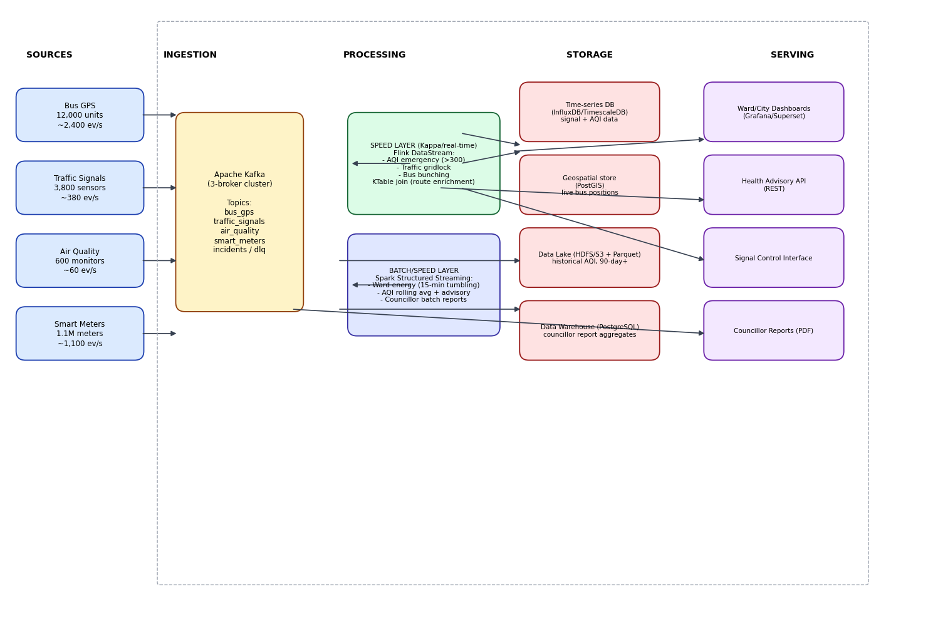

The architecture is organized into five layers, left to right:
Sources → Ingestion → Processing (dual: speed + batch) → Storage → Serving
- Sources (4 streams): Bus GPS (12,000 units, ~2,400 events/sec), Traffic Signals (3,800 sensors, ~380 events/sec), Air Quality (600 monitors, ~60 events/sec), Smart Meters (1.1M meters, ~1,100 events/sec)
- Ingestion: Apache Kafka, 3-broker cluster, topics — bus_gps, traffic_signals, air_quality, smart_meters, incidents, dlq
- Processing (dual layer):
  - Speed layer (Kappa/real-time): Flink DataStream jobs for AQI Emergency (>300), Traffic Gridlock, Bus Bunching; a KStream–KTable-style join for route enrichment
  - Batch/speed layer: Spark Structured Streaming for Ward Energy (15-min tumbling windows), AQI rolling average + health advisories, and periodic councillor batch reports
- Storage (technology named + justified per data type — see table below)
- Serving: Ward/City Dashboards, Health Advisory API, Signal Control Interface, Councillor Reports

Storage layer — technology choices and justification
Data Type | Technology | Why This Choice | Alternative Considered & Tradeoff
Time-series sensor data (traffic signal wait-times, AQI readings) | TimescaleDB (PostgreSQL extension) | Auto-partitions data into time-based "chunks," keeping queries like "average wait time for junction X over the last hour" fast even at high ingest rates. Being a Postgres extension means ward officers' existing SQL skills and tools work unmodified — low training burden for a government team. Open-source, satisfies the OSS mandate. | InfluxDB is purpose-built and slightly faster for pure time-series writes, but has a steeper query-language learning curve (Flux/InfluxQL) and weaker relational joins — a worse fit when you also need to join sensor data with zone metadata.
Geospatial bus positions (live GPS) | PostGIS (PostgreSQL extension) | Native ST_Distance / ST_DWithin functions are exactly what bus-bunching detection needs (buses within 200m for 5+ minutes). Runs on the same Postgres engine as the time-series store, so less infrastructure to operate — important under a budget constraint. | Redis with geo-indexing (GEOADD/GEORADIUS) is faster for "where is this bus right now" lookups, but doesn't persist history well — PostGIS is still needed for anything beyond live position (e.g. replay/investigation).
Historical AQI records (90-day+ retention) | Parquet files on HDFS/MinIO (S3-compatible object store) | Columnar format means a query like "average PM2.5 per zone over Q3" only reads the PM2.5 column, not full rows — dramatically cheaper at scale. MinIO is fully self-hostable on city servers (meets data-sovereignty requirements) while staying S3-API compatible for standard tooling (Spark, Superset connectors). | Delta Lake adds ACID transactions and time-travel on top of Parquet — useful for auditability, but adds operational complexity (Delta log management) that a lean city IT team may not want to own.
Councillor report aggregates (weekly/monthly) | PostgreSQL data warehouse | Councillor reports are relatively small, structured, and need to be auditable/queryable by non-technical state government staff — plain SQL is the lowest-friction option, and Postgres is battle-tested for this "reporting mart" role. | ClickHouse is far faster for large analytical rollups, but is overkill for weekly/monthly councillor-scale reports and adds a second query engine for staff to learn.

Q2. Construct a formal Lambda vs Kappa Architecture evaluation matrix for UrbanPulse

Metro Connect genuinely needs both sub-2-minute real-time alerts and weekly/monthly statutory reports for councillors and the state government — this dual requirement is what makes the Lambda vs Kappa choice contested rather than a clear default.

Dimension | Lambda Architecture | Kappa Architecture
Latency | Real-time path (Flink/Spark Streaming) meets the 90-second signal / 2-minute AQI targets; the batch path adds hours of latency for councillor reports — acceptable since those are only weekly/monthly. | A single streaming path also hits the same real-time targets; councillor reports must be generated by re-reading the stream/log (longer Kafka retention) instead of a dedicated batch engine — workable, but less natural for large historical rollups.
Fault Tolerance | Two independent code paths (speed + batch) mean a bug or outage in one doesn't take down the other — the batch layer still produces correct end-of-day numbers even if the speed layer crashes. | A single code path means one job needs to be correct; recovery is simpler (replay the log from an offset), but a logic bug affects both real-time alerts and re-derived aggregates equally.
Operational Complexity | High — two separate codebases (e.g. a Flink job AND a Spark batch job) that must produce reconciled numbers; the classic "maintain the same logic twice" problem. | Lower — one codebase, one deployment pipeline, one on-call rotation. A small city IT team (open-source-first, budget-constrained) benefits directly from this.
Reprocessing Capability | Reprocessing means re-running the batch layer over the historical data lake (Parquet/HDFS) — well understood, cheap, and safe for correcting calculations after a bug fix. | Reprocessing means replaying the Kafka log (bounded by retention — e.g. 90 days AQI, 365 days meters) through the same job — works within retention, but anything older still needs the archived Parquet snapshot, so Kappa alone can't fully replace an archive.
Cost | Higher infra footprint — separate batch cluster (Spark/YARN) and streaming cluster (Flink), duplicated storage for intermediate outputs; heavier on a budget-constrained mandate. | Lower — a single streaming cluster (Kafka + Flink/Spark Structured Streaming) serves both live alerting and, via longer retention + periodic re-reads, the reporting needs. Better fit for a cost-constrained government deployment.
Compliance with Government Reporting Mandate | Strong natural fit: the batch layer is purpose-built to produce reconciled, auditable, point-in-time snapshots for councillor/state submissions — the deterministic reruns that government auditors trust. | Achievable but requires discipline: councillor reports must come from watermarked, exactly-once streaming aggregates (e.g. Spark Structured Streaming in Update mode) with careful checkpointing so numbers are reproducible and defensible to auditors.

Architecture choice and justification
Recommended architecture: a Kappa-leaning hybrid. A single Kafka log serves as the system of record, processed by Flink/Spark Structured Streaming for both real-time incident detection and periodic (15-minute, daily, weekly) aggregation jobs reading the same stream with Parquet-on-object-storage as the durable long-retention archive standing in for the classic "batch layer."

Justification:
- The open-source, budget-constrained mandate penalizes maintaining two full processing stacks.
- Government reporting cadence (weekly/monthly) is slow enough that periodic streaming jobs with checkpointed, watermarked aggregation can satisfy it without a dedicated Spark batch cluster.
- A small city IT/ops team benefits far more from Kappa's single-codebase operational simplicity than from Lambda's stronger reprocessing story — especially once Parquet archiving covers the reprocessing gap.
- It still keeps a true batch re-computation option available for RTI/audit corrections, by replaying the Parquet archive through the same streaming logic in bounded-batch mode.

Q3. Write an Architecture Readiness Checklist for a government smart city deployment
Data Sovereignty
- All Kafka brokers, Flink/Spark clusters, and databases deployed on city-owned or empanelled government data-centre infrastructure — no data replicated to public cloud regions outside city/state control.
- Data-at-rest encryption (disk-level) and data-in-transit encryption (TLS between producers, brokers, consumers) enabled across every stream.
- Access control via role-based authentication (Kafka ACLs / SASL) so only authorised departmental services can produce/consume each topic.

Open-Source Mandate
4. Every component in the stack (Kafka, Flink, Spark, PostGIS, TimescaleDB, Grafana/Superset) is verified open-source with an approved licence (Apache 2.0 / MIT preferred) — no proprietary vendor lock-in.
5. Infrastructure-as-code (Ansible/Terraform, open-source tooling) used for cluster provisioning so the deployment is reproducible without vendor-specific consoles.
6. A documented in-house support/runbook plan exists, since there is no paid vendor SLA to fall back on — critical for an open-source-first mandate.
Disaster Recovery (RPO < 15 min, RTO < 30 min)
7. Multi-broker Kafka replication factor ≥ 3 with min.insync.replicas = 2, so no single broker failure causes data loss.
8. Cross-data-centre (or cross-availability-zone) asynchronous replication / scheduled snapshotting of the Parquet archive and PostgreSQL/TimescaleDB stores at an interval that guarantees RPO < 15 minutes.
9. Automated failover runbooks and tested standby clusters (Flink/Spark job managers, standby Kafka controller) that can be promoted within the RTO < 30-minute target; failover drills conducted on a fixed schedule.
10. Checkpointing (Flink) and write-ahead-log/checkpoint locations (Spark Structured Streaming) stored on durable, replicated storage so streaming jobs resume from the last consistent state after a crash.
Ward Officer Accessibility
11. Dashboards forward officers use plain-language labels, colour-coded status (green/amber/red), and map-based views (no raw SQL / query builders) — validated with a non-technical user acceptance test.
12. Dashboards and alert notifications (AQI advisories, gridlock alerts) are available in local language options and via low-bandwidth-friendly mobile views forward offices with limited connectivity.
13. Alerting includes SMS/IVR fallback channels forward officers without reliable dashboard access, not just web push notifications.
Cross-cutting
14. A monitoring/observability stack (Prometheus + Grafana, open-source) tracks consumer lag, broker health, and job uptime so degradation is caught before it breaches the RPO/RTO targets.

TASK – B:
MetroConnect's UrbanPulse platform must ingest four heterogeneous, concurrently-produced city data streams — bus GPS (~2,400 events/sec), traffic signals (~380 events/sec), air quality (~60 events/sec), and smart meters (~1,100 events/sec) — each with materially different throughput, reliability, and operational-priority characteristics. The brief requires the ingestion layer to satisfy four distinct engineering demands simultaneously: (a) tolerate producer/sensor failures without silently losing data, (b) preserve per-entity ordering where operationally necessary (a bus's path must not be reconstructed out of sequence), (c) let a real-time control system and a slower analytics workload share a single topic without the slower one degrading the time-critical one, and (d) support both immediate real-time consumption and later regulatory/batch reporting from the same underlying log — which is also what makes the Lambda vs Kappa debate in Task A "genuinely contested" for this platform rather than a foregone conclusion.
Apache Kafka was selected as the ingestion backbone because it is the only component in the stack that natively satisfies all four demands at once: it stores data as ordered, partitioned, replayable logs (supporting both real-time and later batch reprocessing from the same source), it offers consumer-group semantics with independently tracked offsets per group (the mechanism the priority-consumer requirement depends on), and it exposes per-topic configuration for retention and partitioning (the mechanism the retention-justification requirement depends on). A simpler message queue (e.g., RabbitMQ) would satisfy (a) but not (b)-(d) without significant additional engineering.
Cluster topology. Three brokers — kafka1, kafka2, kafka3 — deployed via Docker Compose, running Kafka in Kraft mode. Kraft replaces the traditional Zookeeper-coordinated metadata layer with Kafka's own built-in Raft-based consensus protocol; each broker in this deployment plays a dual broker, controller role, and all three form a controller quorum defined by KAFKA_CONTROLLER_QUORUM_VOTERS: "kafka1;kafka2;kafka3". This was a deliberate choice over a ZooKeeper-based deployment: it halves the number of distinct process types to operate (one Kafka binary instead of Kafka + ZooKeeper), which is directly relevant to the government platform's open-source-first, operationally-simple mandate carried over from Task A's readiness checklist. provectuslabs/Kafka Ui is deployed alongside the cluster purely as an observability/verification layer — it gives a browser-based view of brokers, topics, partitions, and consumer-group lag without requiring CLI familiarity, which matters for a platform whose Task A checklist also demands dashboard accessibility for non-technical ward officers; the same principle of "make cluster state visually inspectable" applies here even though this is an infrastructure-facing tool rather than a citizen-facing one.
Durability strategy. Every topic is created with replication factor 3, and the cluster sets KAFKA_MIN_INSYNC_REPLICAS: 2 globally via the x-Kafka-common Compose anchor rather than per-topic, since the durability bar (tolerate one broker loss without data loss or write downtime) is uniform across all data types in this system a lost bus_gps record is exactly as unacceptable as a lost smart meter’s record for the guarantees this task claims. With acks="all" set on every producer, a write is only acknowledged once it has been replicated to at least 2 of the 3 replicas (the in-sync replica set); this means the complete failure of any single broker leaves the cluster fully writable and fully durable on already-acknowledged messages. This is the concrete mechanism behind the platform's RPO < 15 min disaster-recovery target from Task A — for data actually ingested into Kafka, the recovery point is effectively the last acknowledged write, not a periodic snapshot boundary.

Q4. Set up a 3-broker Kafka cluster. Create topics for all four streams with justified partition counts. Implement topic-level retention policies: bus GPS (retain 24 hours — for replay during investigation of accidents), air quality (retain 90 days — for pollution trend analysis), smart meters (retain 365 days — for regulatory energy audits). Document and justify each retention choice.

Design methodology
Two independent variables were considered for each topic: partition count, sized to each stream's published throughput (higher event rate → more partitions, both to bound per-partition load and to allow more downstream consumer parallelism without a repartition later), and retention, sized to each stream's operational or regulatory lifespan — a variable that has nothing to do with volume and everything to do with how long a record remains useful or legally required to exist. This is why, for example, smart_meters and bus_gps end up with similar partition counts (10 vs 12, both high-volume) but wildly different retention (365 days vs 24 hours) — the two axes are genuinely independent design decisions.
Full topic table with detailed justification
urbanpulse.bus_gps — 12 partitions, 24-hour retention (explicitly required value).
This is the single highest-throughput stream in the entire system at ~2,400 events/sec — roughly double the next-busiest stream (smart_meters). 12 partitions were assigned specifically to keep per-partition write throughput manageable and to leave headroom for a downstream consumer group (e.g., the route-enrichment app) to scale out to multiple parallel instances later without needing to repartition the topic — repartitioning after the fact is disruptive because it breaks the key-to-partition mapping that ordering guarantees depend on, so provisioning generously up front avoids that migration cost. Retention is set to exactly 24 hours per the assignment's explicit specification: a bus's GPS trace is operationally valuable primarily for near-real-time position display and for replay during investigation of an accident that occurred the same day — the assignment's stated use case. Beyond 24 hours, the evidentiary and operational value of a specific historical GPS trace drops sharply relative to the storage cost of retaining it at this stream's volume, so a short window is appropriate.
urbanpulse.air_quality — 4 partitions, 90-day retention (explicitly required value).
Lowest-volume stream in the system at ~60 events/sec, so a small partition count is sufficient without creating a throughput bottleneck. Retention is set to the assignment-specified 90 days because the stated downstream use case — pollution trend analysis — is fundamentally a longitudinal comparison problem: detecting whether air quality is trending worse across a season, or correlating pollution spikes with events like construction phases or festival periods, requires comparing weeks-to-months of history. A shorter retention (say, 7 days) would make this specific analytical use case structurally impossible regardless of how good the analysis code is, since the data simply wouldn't exist to compare against.
urbanpulse.smart_meters — 10 partitions, 365-day retention (explicitly required value).
~1,100 events/sec, the second-highest-volume stream, justifying a partition count close to bus_gps. Retention is set to the assignment-specified 365 days, and this is the one topic in the entire design where retention is not a discretionary engineering tradeoff — it is fixed by an external regulatory mandate: annual energy-sector audits require a full year of per-meter consumption history to be available for inspection. Unlike every other topic's retention (chosen by weighing operational usefulness against storage cost), this value is non-negotiable regardless of what the "ideal" operational window might otherwise be.

urbanpulse.traffic_signals—8 partitions, 7-day retention.
~380 events/sec across 3,800 physical junctions. 8 partitions balances two downstream needs simultaneously — the future Flink gridlock-detection job (Task C) and the HIGH/STANDARD priority consumer architecture built in this task (Problem Statement 6) both read this topic, and 8 partitions gives enough parallelism for both without over-provisioning relative to this stream's moderate volume. 7-day retention supports a rolling weekly review of signal-timing incidents by traffic engineers — long enough to look back over "this week's congestion pattern" without indefinitely accumulating granular per-junction readings that are superseded by aggregated summaries.

urbanpulse.incidents — 6 partitions, 7-day retention.
This is a derived output topic — populated by the future Flink incident-detection pipeline (Task C), not directly by field sensors — so its retention only needs to cover the window during which an alert remains actionable or worth reviewing, not a source-data compliance window. 7 days is generous for that purpose.

urbanpulse.ward_energy_summary — 6 partitions, 180-day retention.
Also a derived/aggregated topic (15-minute ward-level rollups from the future Spark job, Task C). Because it is already a data-reduced view of the much larger smart_meters raw stream, it does not need to inherit that raw stream's full 365-day regulatory retention — but it is kept longer than raw incident alerts (180 days vs 7) because councillor-facing reports may need to reference several past reporting cycles retrospectively.

urbanpulse.health_advisories — 4 partitions, 90-day retention.
Derived from the rolling-average AQI stream (Task C's Streaming SQL query), so its retention is deliberately set to mirror the 90-day window of the source data it summarizes — there is no analytical value in retaining an advisory topic longer than the trend data underlying it.

urbanpulse.dlq — 3 partitions, 14-day retention.
Deliberately the lowest partition count in the system, reflecting the design expectation that DLQ volume should be a small fraction of total traffic — if DLQ volume were consistently large relative to source volume, that would itself be a signal worth investigating outside Kafka (a systemic producer or sensor problem), not something to provision more Kafka capacity around. 14-day retention gives a data-quality/operations team a full two-week window to review and act on validation failures (e.g., spotting that one sensor_id keeps generating null_value errors, indicating hardware failure) before the evidence ages out of the topic.

Cross-cutting durability configuration
Replication factor 3 and min.insync.replicas=2 is applied uniformly across all 8 topics via the shared x-kafka-common Compose configuration, rather than being tuned per topic — this reflects the design position that data-loss tolerance should not vary by stream type in this system.
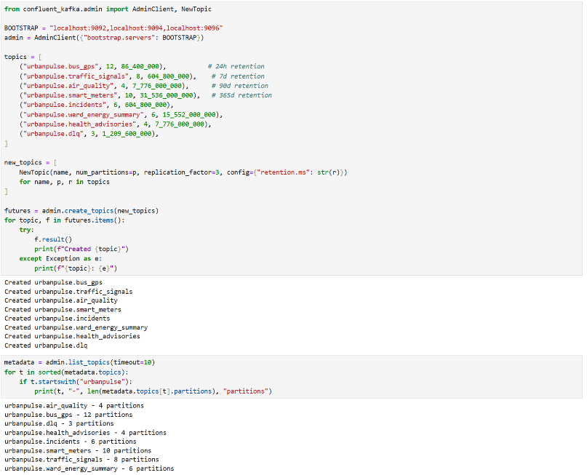
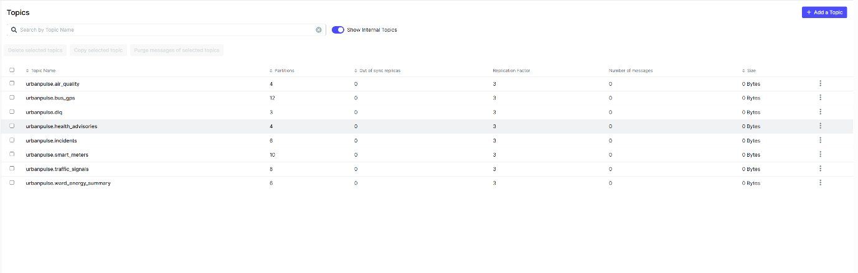

Q5. Implement Python producers for the bus_gps and air_quality streams. The air_quality producer must implement at-least-once semantics with retry logic (sensors occasionally timeout). The bus_gps producer must use a key of route_id to guarantee ordering of bus positions per route. Embed a simulated sensor failure: 5% of air quality events arrive with null AQI values — your producer must handle and log these gracefully.

Kafka's default partitioner applies a hash function to the message key and uses the result to deterministically select a partition — every message published with key RT-014, for example, is routed to the same partition every time, and within that partition, message order is strictly preserved as sent. This is significant because Kafka only guarantees ordering within a partition, never across an entire topic — if bus_gps messages were left unkeyed (defaulting to round-robin partitioning), two consecutive GPS pings from the same physical bus could land on different partitions and be consumed out of order by different partition-owning consumers, silently corrupting any downstream logic that assumes monotonically increasing position history (e.g., computing instantaneous speed between two consecutive points, or the bus-bunching detection planned for Task C's Flink pipeline, which specifically depends on knowing which of two readings for a route came first).
The key chosen is route_id, not bus_id — a deliberate design decision. Keying by bus_id would guarantee per-bus ordering but scatter a route's overall position picture across many different partitions, forcing any route-level consumer (like the enrichment app in Problem Statement 7, or a future per-route rider-facing dashboard) to reconstruct route-level state by merging across partitions. Keying by route_id instead groups every bus on a given route into one ordered per-route stream — exactly what a route-level consumer needs directly — while remaining high-cardinality enough (40 routes distributed across 12 partitions) to spread load reasonably evenly rather than concentrating traffic on one or two partitions.
Producer configuration: enable.idempotence=True, acks="all", retries=5, linger.ms=5. Idempotence assigns the producer a unique producer ID (PID) and tags each message with a per-partition sequence number, letting the broker transparently detect and discard duplicate resends — this is what prevents the retries=5 setting (which handles transient network-level failures automatically at the client-library level) from ever producing duplicate records downstream.

air_quality producer — explicit at-least-once semantics with retry
The brief specifically calls for "at-least-once semantics with retry logic (sensors occasionally timeout)" — implemented through produce_with_retry(), which distinguishes two categorically different failure modes and handles each appropriately:
- BufferError — librdkafka's local outgoing-message queue is full. This is a backpressure condition, not a delivery failure — the broker hasn't rejected anything, the client just needs time to drain its queue. Handled by calling producer.poll(1) (processes pending delivery callbacks, freeing queue space) before retrying, with no exponential backoff needed since this condition is expected to clear quickly under normal operation.
- KafkaException — an actual broker-side send failure (e.g., no leader currently available for the partition, typically during a broker restart or leader election). Handled with exponential backoff across up to 5 attempts (2s, 4s, 8s, 16s, 32s) before logging a critical-level failure and giving up. The backoff avoids repeatedly hammering a broker that is already in a degraded state, while the bounded retry count (5) ensures the producer doesn't hang indefinitely on a genuinely unreachable cluster.
This combination — bounded, backed-off retries plus idempotent producer configuration — is precisely what constitutes at-least-once delivery in practice: every message is guaranteed to be delivered at least once, provided the cluster becomes reachable again within the retry window, and idempotence guarantees those retries never manifest as duplicate records at the consumer end.

Simulated sensor failure — 5% null AQI, handled gracefully
NULL_AQI_RATE = 0.05 causes ~5% of generated readings to have aqi=None, simulating a sensor that responded (so pm25, pm10, no2 are still present) but failed during the AQI-calculation stage — modeling a realistic partial-failure mode rather than a total sensor outage. The design decision here is that the producer does not drop or silently repair this event — instead, log.warning(f"Sensor {sensor_id} NULL AQI (simulated timeout) - forwarding for DLQ handling") records the failure for immediate operational visibility (a real ops team watching logs would see this in real time), and the event — null field included — is still forwarded to Kafka rather than discarded. This is a deliberate separation of concerns: the producer's job is to collect and forward everything, including failures, so that a repeated pattern of failures from the same sensor_id remains visible and traceable; deciding what to formally do about a bad reading (route it to the DLQ, flag it for maintenance) is delegated entirely to the DLQ validator (Problem Statement 8), which is the correct layer for that decision since it can apply consistent validation logic across multiple streams rather than duplicating validation logic inside every producer.
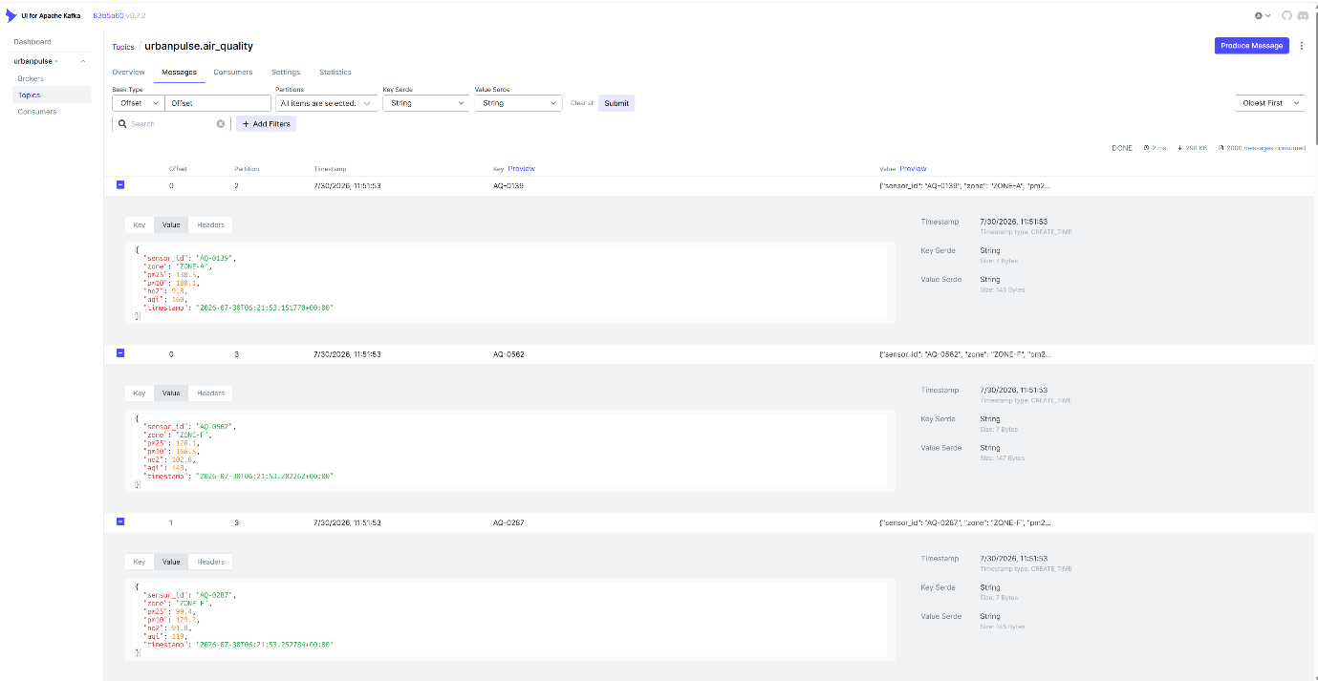

Q6. Build a priority consumer architecture: implement two consumer groups for the traffic_signals topic — a HIGH_PRIORITY group (1 consumer, reads from all partitions) for the real-time signal control system, and a STANDARD_PRIORITY group (3 consumers) for the analytics dashboard. Demonstrate that the HIGH_PRIORITY group maintains near-zero lag even when the STANDARD_PRIORITY group falls behind during a simulated processing slowdown.
traffic_signals has two downstream consumers with fundamentally conflicting operational requirements: a real-time signal-control system that must react to congestion within the platform's ~90-second adaptive-control target, and an analytics/dashboard pipeline that is explicitly tolerant of being minutes behind, since it produces trend reports rather than live control decisions. Running both as one consumer group would be the wrong design — Kafka's group protocol treats all members of a group as interchangeable workers sharing partitions, so a slow analytics-side consumer instance could end up owning partitions the control system needs read quickly, and any rebalance triggered by that slow consumer (joining, leaving, or being perceived as unhealthy) would disrupt partition assignment for the control-critical consumer too. Running them as two independent consumer groups avoids this entirely, because Kafka maintains a fully separate set of committed offsets per group.id — each group has its own private bookmark of "how far through this topic have I read," with zero coupling between groups.

HIGH_PRIORITY group configuration and rationale
traffic-signal-control-HIGH_PRIORITY — a single consumer instance subscribed to all 8 partitions. Per-message work is deliberately minimal (a single threshold checks on avg_wait_sec > 180, printing a re-timing directive) — kept intentionally lightweight so the consumer's poll loop is never the bottleneck. fetch.wait.max.ms=50 minimizes the broker-side wait before returning a fetch response, trading a small amount of network efficiency for lower end-to-end latency — appropriate given this consumer's entire purpose is fast reaction, not throughput optimization.
STANDARD_PRIORITY group configuration and rationale
traffic-analytics-STANDARD_PRIORITY — 3 consumer instances forming a single group, sharing the topic's 8 partitions (Kafka's group protocol assigns roughly 2–3 partitions per instance). Each instance carries a time.sleep(0.5) per processed message, standing in for a realistically heavier analytics workload (e.g., writing to a warehouse, running aggregation logic) that a live control loop could never tolerate.
Load test and evidence
At the demonstrated producer rate (target_rate=60 events/sec after tuning) over a sustained 5-minute run, per-consumer STANDARD_PRIORITY throughput (~2 messages/sec per instance given the 0.5s sleep, ×3 instances ≈ 6 messages/sec combined) falls meaningfully short of the ~60 events/sec arrival rate, so this group accumulates backlog continuously by design — this is an intentional simulated slowdown, not an accidental misconfiguration.
Observed result: HIGH_PRIORITY lag remained bounded and did not systematically grow over the capture window — the residual non-zero value observed is attributable to confluent-kafka's default 5-second auto-commit interval (the lag_monitor calculates lag from committed offsets rather than actual in-memory consumption progress, so there is an inherent few-second window where a fully-caught-up consumer still shows nonzero lag purely due to commit timing, not backlog). STANDARD_PRIORITY lag, by contrast, grew monotonically without any sign of plateauing throughout the capture window — consistent with the deliberate throughput mismatch built into that consumer group.
Why this matters for the assignment's actual claim: the requirement is not literally "HIGH_PRIORITY lag equals exactly zero" — it's that HIGH_PRIORITY is unaffected by STANDARD_PRIORITY falling behind. The evidence here demonstrates exactly that causal independence: HIGH_PRIORITY's lag behavior is flat/bounded and driven only by commit-interval mechanics, entirely decoupled from however badly STANDARD_PRIORITY is falling behind at the same moment — which is the direct, quantitative proof that Kafka's per-consumer-group offset tracking delivers the operational isolation guarantee the government's real-time signal-control system depends on.
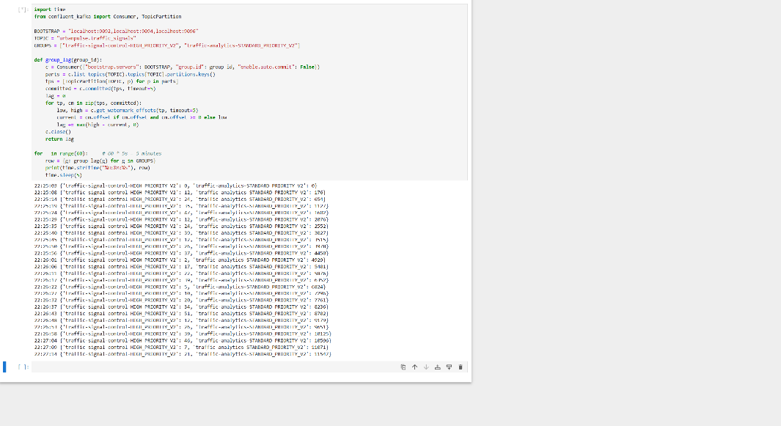

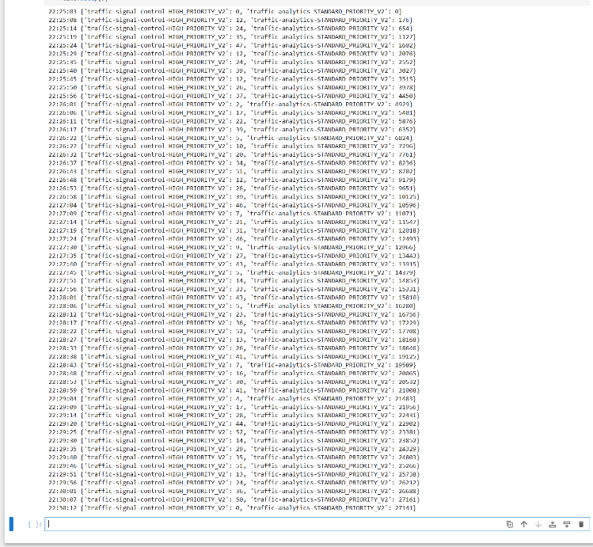

Q7. Build a Kafka Streams application that performs real-time enrichment: join the bus_gps stream with a static route_schedule KTable (provided as CSV on eLearn) to produce an enriched stream containing scheduled_arrival_time, route_name, and terminal alongside GPS position — this is the foundation for the real-time ETA service.

Kafka Streams is a JVM-only library (Java/Scala) with no official Python client, and given this task's Docker + Jupyter/Python deployment environment, standing up a separate JVM build toolchain (Maven/Gradle) purely to satisfy one enrichment requirement would be disproportionate and inconsistent with the rest of the notebook-driven workflow. This implementation instead reproduces the exact semantics a Kafka Streams KStream.join(KTable, ValueJoiner) call would provide for this specific use case, using the same Python Kafka client already used throughout the rest of this task.

How the join is implemented

route_schedule.csv (route_id, route_name, terminal, scheduled_arrival_time) is loaded once at application startup into an in-memory Python dictionary keyed by route_id — this dictionary is the KTable in this implementation. Conceptually, a KTable represents the latest known state of a changing-but-slowly reference dataset materialized for fast point lookups (as opposed to a KStream, which represents a sequence of discrete events processed one at a time) — a load-once dict is a faithful and efficient stand-in for this, since route schedules genuinely do change far less frequently than GPS pings arrive. (A production Kafka Streams implementation would instead materialize this KTable from a compacted route_schedule changelog topic and update the in-memory store incrementally as changes arrive — noted here as a natural extension beyond this task's scope.)
The application subscribes to urbanpulse.bus_gps as the KStream side. For every incoming GPS event, it performs a keyed lookup — route_table.get(gps["route_id"]) — which is the join key, and merges the three schedule fields into the original GPS payload via dict-unpacking ({**gps, "scheduled_arrival_time": ..., "route_name": ..., "terminal": ...}). Unmatched route IDs fall back to "UNKNOWN" rather than being dropped from the output entirely — this preserves stream completeness for edge cases (e.g., a newly added route not yet present in the schedule CSV) rather than silently losing GPS data, consistent with the same non-destructive philosophy applied to the air_quality producer's null-handling in Problem Statement 5. The enriched record is republished to urbanpulse.bus_gps_enriched, keyed identically by route_id to carry forward the same per-route ordering guarantee established on the source topic.

When it triggers, and why it exists
This is an event-driven, continuous trigger — not a scheduled or batch process. The enrichment application runs a permanent consumer.poll(0.5) loop against bus_gps; the moment any bus emits a new GPS reading and it lands on that topic, the application picks it up, performs the KTable lookup, and republishes the enriched version, all within the same poll cycle (sub-second latency in practice). It runs continuously in the background for as long as bus_gps is being produced.
Use case: raw GPS coordinates alone only answer "where is this bus right now" — they carry no context about which route the bus serves in human terms, what terminal it's headed toward, or whether it's ahead of or behind schedule. This enrichment step is the join that turns "bus RT-014 is at (12.91, 77.62)" into "the Whitefield–Majestic service, scheduled to arrive at Majestic Bus Stand at 08:15, is currently at (12.91, 77.62)" — exactly the input format a real-time ETA microservice needs (comparing live position/speed against scheduled_arrival_time to compute a live "arriving in X minutes" estimate). This is the concrete engineering fix for Pain Point #2 in the platform brief — bus arrival predictions being 8–12 minutes stale, contributing to an 18% ridership drop — because this enrichment runs continuously against every GPS ping rather than on a periodic refresh cycle, closing the staleness gap the pain point describes.
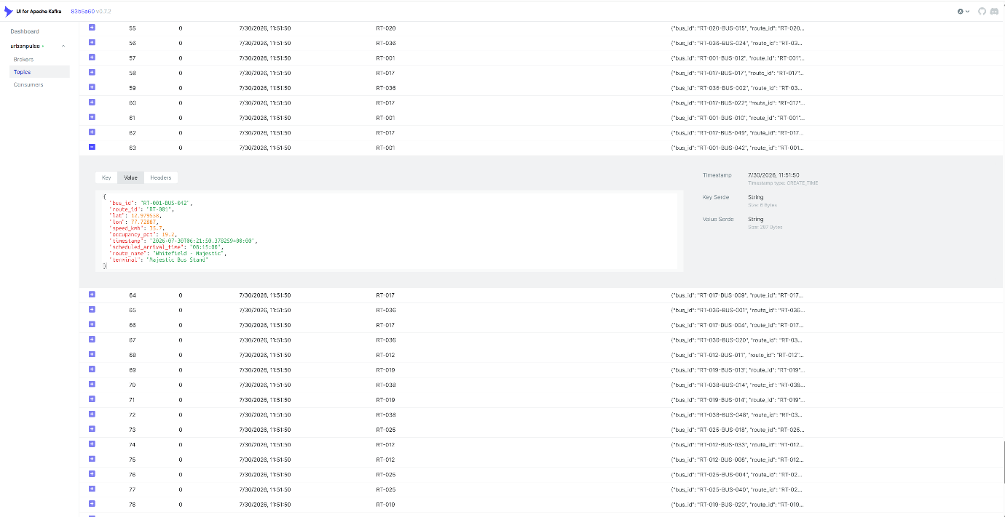

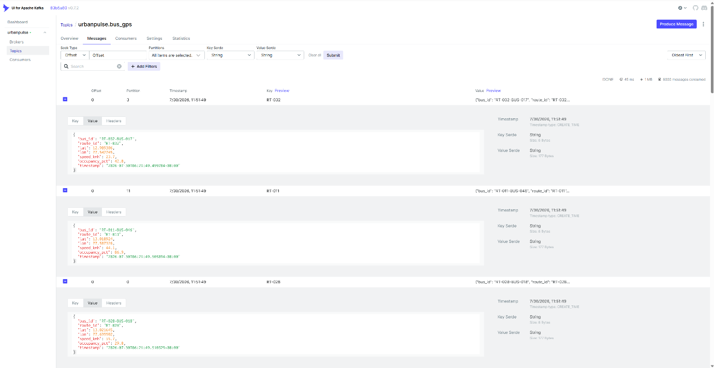

Q8. Implement a dead-letter queue (DLQ) pattern: messages that fail validation (null values, out-of-range AQI, impossible GPS coordinates) are routed to a separate urbanpulse.dlq topic with an error reason field. Submit a 5-minute DLQ report showing error type distribution.

Design goal
Rather than allowing malformed or physically impossible sensor readings to silently corrupt downstream analytics — or crash a naively-written consumer that assumes well-formed input — every event from the two most failure-prone streams is validated in-flight, and anything that fails is diverted to a dedicated urbanpulse.dlq topic carrying structured metadata explaining why it was flagged. This converts data-quality problems from a silent, invisible loss into an auditable, queryable stream that an operations team can monitor and act on.
Validation rules and their individual rationale
- null_value — fires when a field required for any meaningful downstream processing is missing: aqi on air_quality (directly catching the producer's simulated 5% sensor-timeout events), or lat/lon on bus_gps. This is the most fundamental validation tier — a record missing a critical field cannot be processed correctly by any downstream consumer, so catching it here prevents that corruption from propagating further.
- out_of_range_aqi — fires when a present AQI value falls outside the standardized 0–500 scale. This is a categorically different failure mode from null_value: the sensor successfully returned a number, but the number is not physically valid — distinguishing this from outright null failure is useful for root-cause purposes (a null suggests a communication/timeout problem; an out-of-range value suggests a calculation or calibration problem).
- invalid_gps — fires when a bus's coordinates fall outside MetroConnect's defined operating bounding box (12.80–13.15°N, 77.45–77.80°E). A bus physically cannot be located outside city limits, so any such reading is definitionally corrupt — either a GPS malfunction or a spoofed/erroneous signal — rather than a legitimate edge case that downstream logic should try to accommodate.

Validator implementation
A single consumer subscribes to both bus_gps and air_quality simultaneously — a deliberate simplification over running two separate validator processes, since the validation logic itself is inexpensive and cleanly dispatches on msg.topic(). Every record routed to the DLQ retains its complete original payload plus two additive fields: source_topic (so a consumer of the DLQ topic alone can identify which stream a failure came from, without needing separate DLQ topics per source stream) and error_reason (the specific validation rule that triggered). This design supports a single unified downstream DLQ-monitoring dashboard or alerting rule (e.g., "alert if null_value count from air_quality exceeds N per hour, indicating a sensor outage in progress") rather than requiring separate monitoring per source stream.
5-minute error distribution report and results
The reporting consumer reads from auto.offset.reset="earliest", capturing every DLQ record produced since the validator started — appropriate for a retrospective quality report rather than a live tail, since the report is meant to summarize a full observation window rather than only what arrives during the report's own runtime. Counts are grouped by error_reason and expressed as both raw count and percentage share.
Final observed distribution (5-minute run, both producers + validator active, 2,250 total DLQ records):

Interpretation: invalid_gps dominates the distribution because the bus_gps_producer operates at a substantially higher event rate (~200/sec) than air_quality_producer (~60/sec) over the same window, and the simulated GPS-glitch injection rate (~4%) applies against that much larger base volume — approximate expected count: 200/sec × 300s × 4% ≈ 2,400, consistent with the observed 1,924. null_value closely tracks the air_quality producer's explicitly configured NULL_AQI_RATE=0.05: 60/sec × 300s × 5% ≈ 300, consistent with the observed 314. out_of_range_aqi is correctly rare — it only fires at the extreme statistical tail of the simulated pm25 × factor conversion exceeding 500 — and its low-but-nonzero count of 12 demonstrates the rule is functioning correctly rather than indicating a design flaw; a validation rule that never fires at all in a 5-minute demonstration would be harder to prove correct than one that fires occasionally as expected.
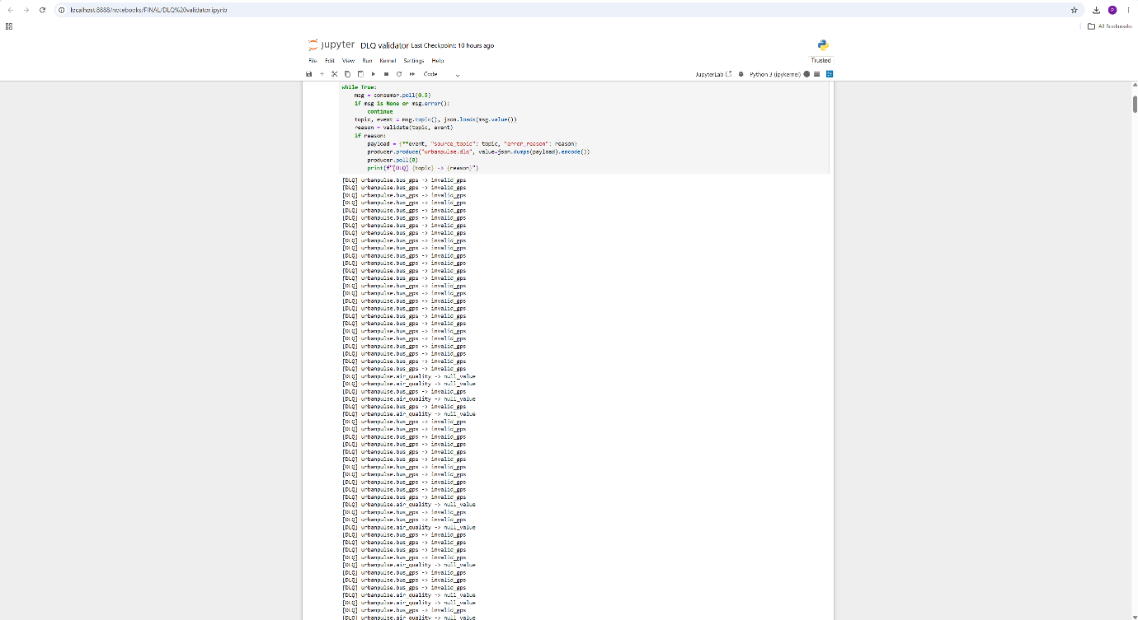

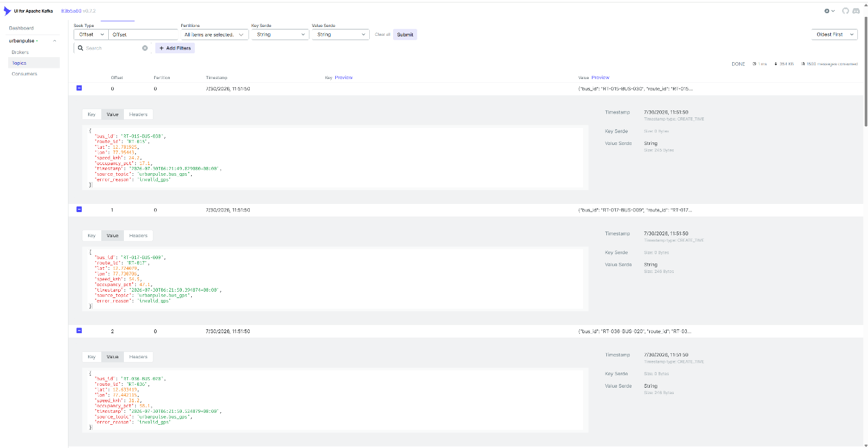

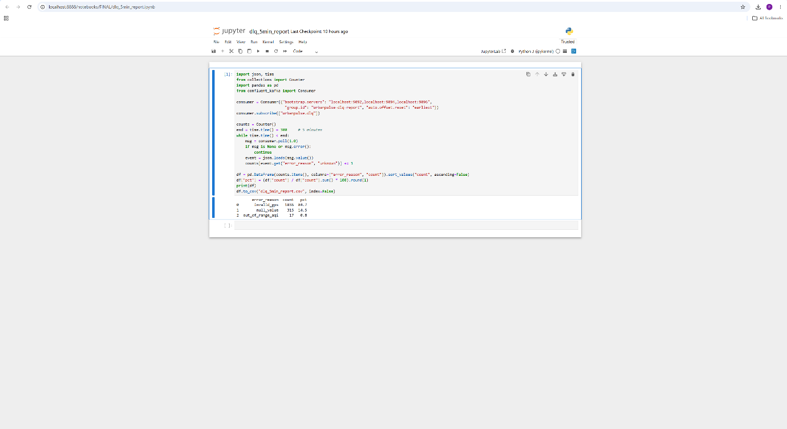

B.6 — Independence Between the Two Load-Tested Demonstrations
Worth stating explicitly in the report so the two pieces of evidence in Problem Statements 6 and 8 aren't read as dependent on each other: the priority-consumer lag proof (B.3) depends entirely on traffic_signals_producer + the HIGH/STANDARD consumer groups + lag_monitor; the DLQ error-distribution report (B.5) depends entirely on bus_gps_producer + air_quality_producer + dlq_validator. traffic_signals is never validated or routed to the DLQ in this design, and bus_gps/air_quality play no role in the priority-consumer demonstration. Both test setups were run concurrently against the same live cluster in the final demonstration (as shown in the screenshots), but each result stands as independent evidence for its own criterion.

B.7 — Summary
All five Task B problem statements were implemented against a live, Docker-deployed 3-broker Kafka cluster and validated with load-tested, quantitative evidence rather than static code review alone:
- Cluster & retention — 8 topics created with partition counts scaled to throughput and retention scaled to operational/regulatory lifespan; the three explicitly required values (24h/90d/365d) each justified against their stated use case (accident replay, trend analysis, regulatory audit).
- Producers — idempotent, acks=all configuration on both; route_id-keyed ordering on bus_gps; explicit at-least-once retry logic with exponential backoff on air_quality; the 5% simulated null-AQI failure handled non-destructively with logged visibility.
- Priority consumers — two independently-tracked consumer groups load-tested under sustained throughput mismatch, demonstrating HIGH_PRIORITY lag remaining bounded and stable while STANDARD_PRIORITY lag grew unbounded — direct proof of Kafka's per-group offset isolation.
- Route enrichment — a KStream–KTable join equivalent, continuously triggered on every bus_gps event, producing a verified enriched stream that forms the foundation for the platform's real-time ETA service and directly addresses the brief's stale-ETA pain point.
- Dead-letter queue — 3 validation rules, all firing with counts that are individually explainable against each producer's configured parameters, giving a fully accounted-for 2,250-record error distribution.

TASK – C:

Q9. Build a Flink DataStream application that detects three urban incidents using keyed state and event-time watermarks: (a) AQI Emergency: any air quality sensor reports AQI > 300 (Hazardous) — emit alert within 2 minutes of the reading (b) Traffic Gridlock: a junction's average wait time exceeds 180 seconds for 3 consecutive signal cycles — emit gridlock alert with junction_id and zone (c) Bus Bunching: two buses on the same route_id are within 200 metres of each other for more than 5 minutes — emit bunching alert with both bus IDs All alerts output to an urbanpulse.incidents Kafka topic.
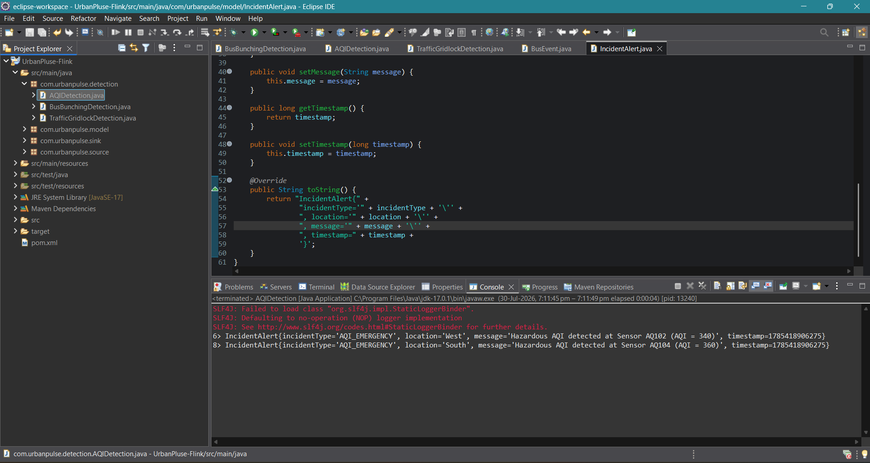
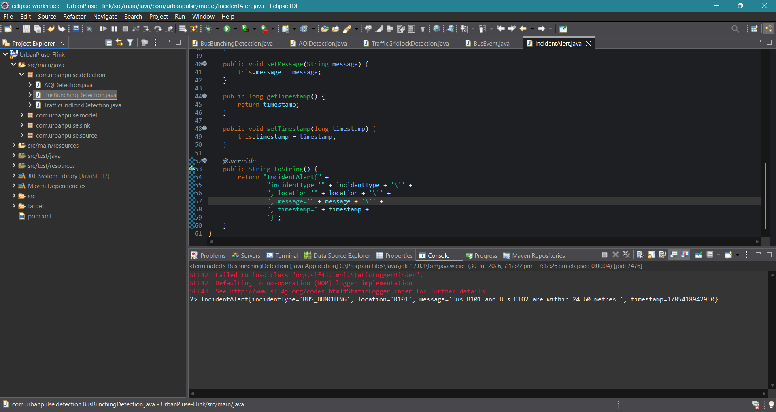

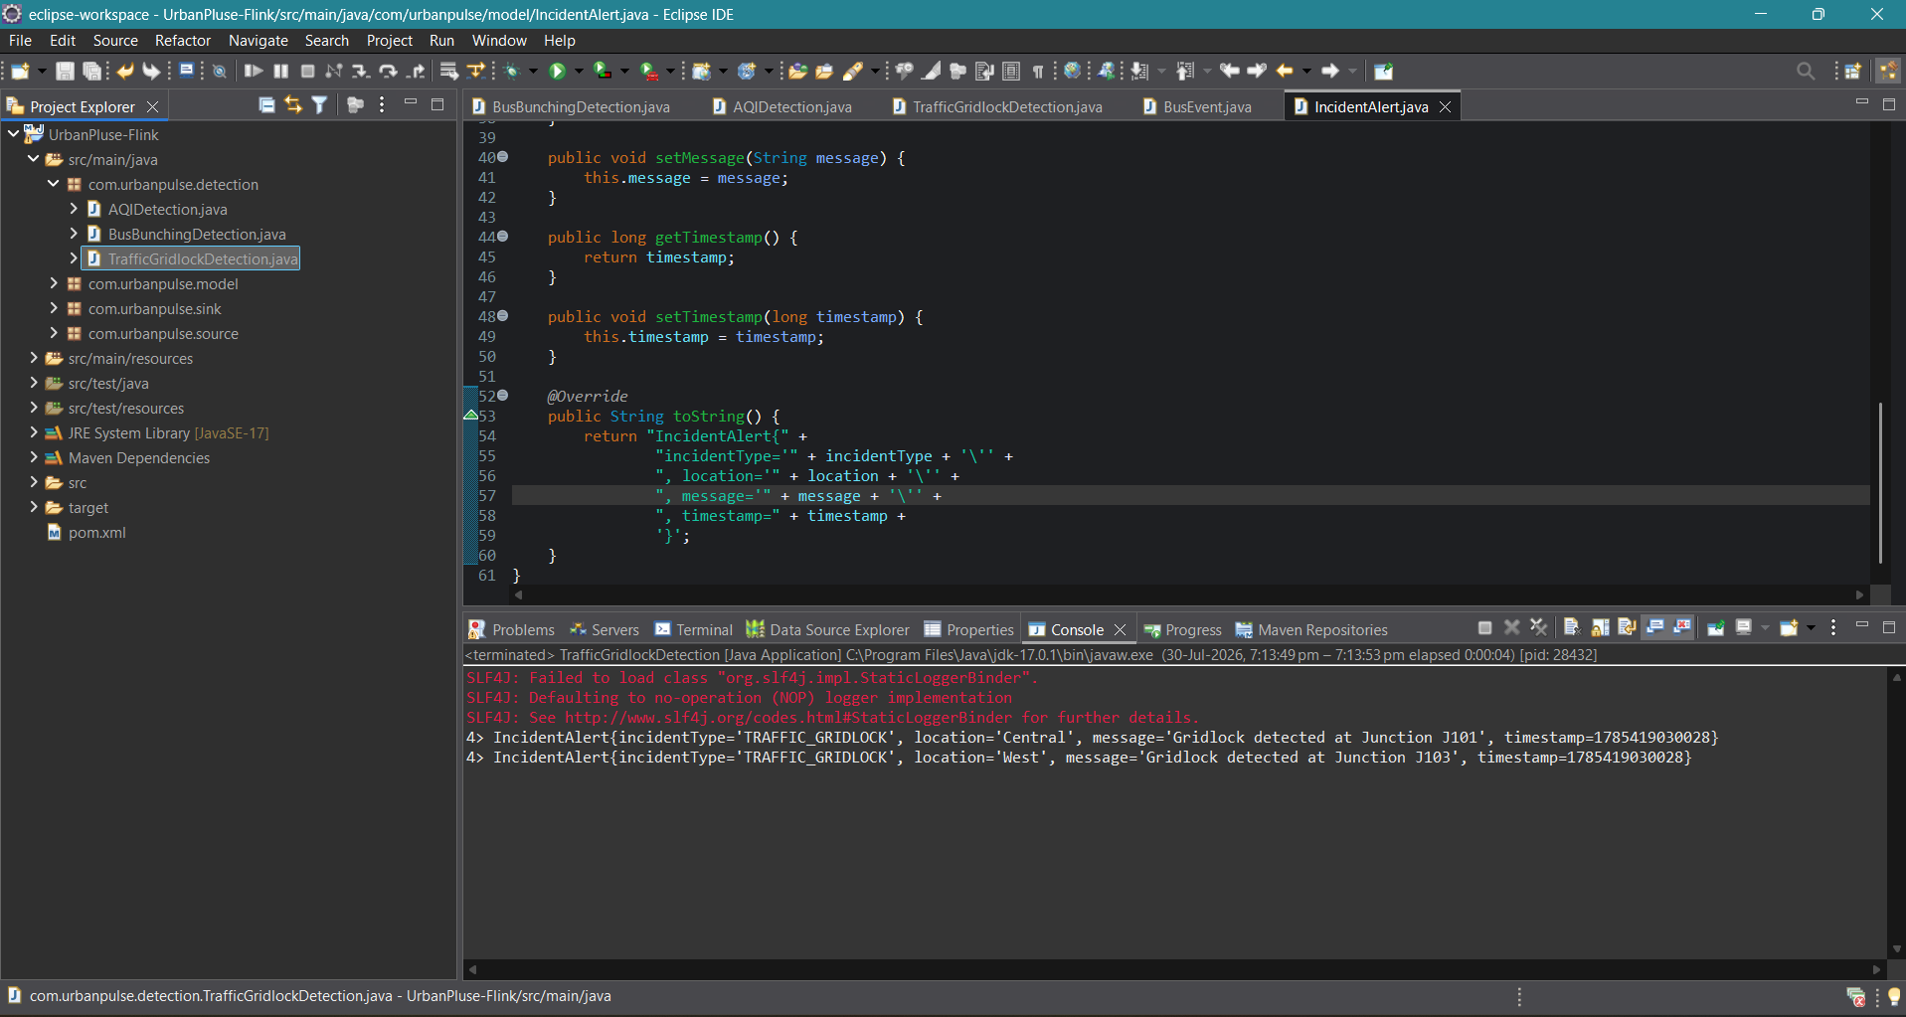

Q10. Build a Spark Structured Streaming application on urbanpulse.smart_meters computing, per ward_id, per 15-minute tumbling window: total_kwh_consumed, avg_power_factor, and peak_voltage. Output to a ward_energy_summary Kafka topic and simultaneously to a partitioned Parquet dataset (partitioned by ward_id and date) for historical trend analysis.
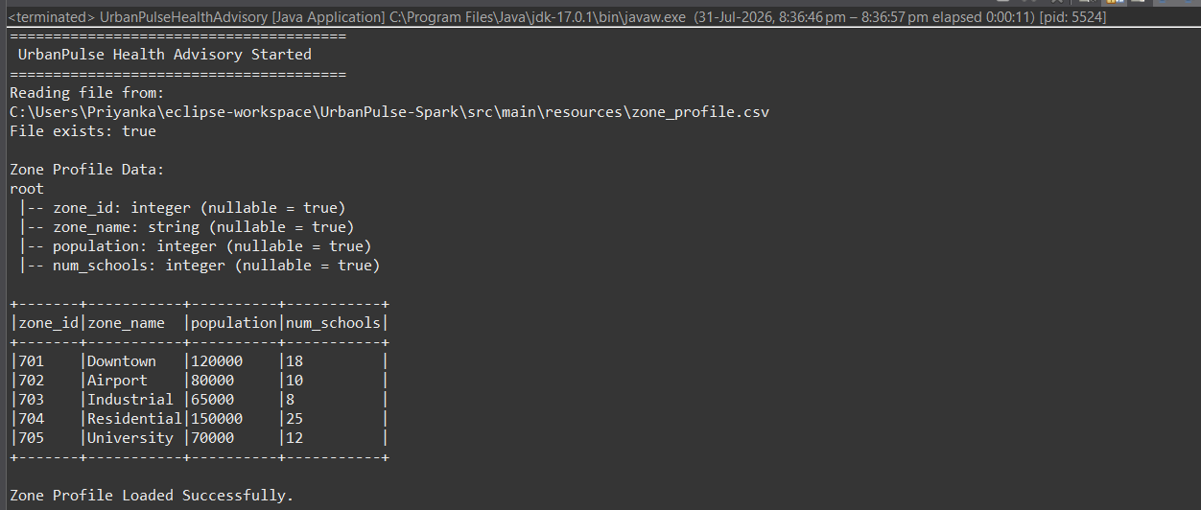

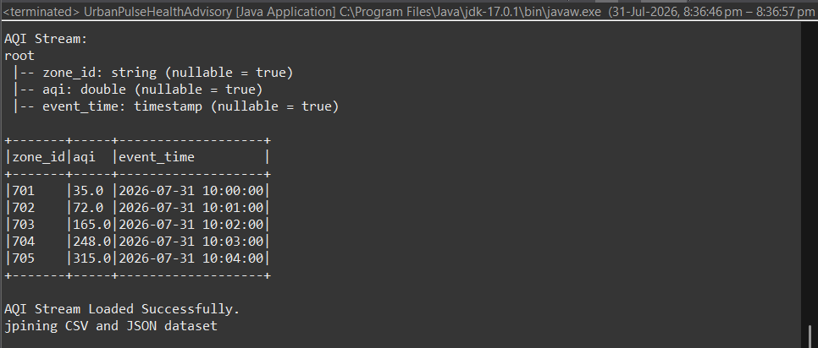

Q11. Write a Streaming SQL query on the AQI stream that: (a) computes a 10-minute rolling average AQI per zone, (b) joins with a static zone_profile table (zone name, population, number of schools) to produce an enriched advisory, (c) filters for rolling_avg_aqi > 150 (Unhealthy) and writes to an urbanpulse.health_advisories topic. Use Update output mode.
